1. **What is transient response? What is first order circuit? What is second order circuit? What is Zero-Input response, Zero-State response and full response?**

**# Transient Response:**

The transient response is the circuit’s temporary response that will die

out with time. The transient response essentially dies out after five-time constants. At that time, the inductor becomes a short circuit, and the voltage across it is becomes zero.

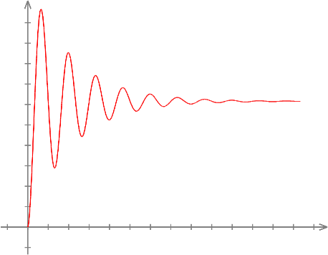

*Example of transient response of a circuit.*

**# First Order Circuit:**

First order circuits are circuits that contain only one energy storage element (capacitor or inductor), and that can, therefore, be described using only a first order differential equation. The two possible types of first-order circuits are:

RC (resistor and capacitor)

RL (resistor and inductor)

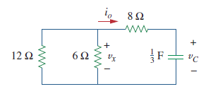

*Example of a first order circuit*

**# Second-Order Circuit:**

A second-order circuit is characterized by a second-order differential equation. It consists of resistors and the equivalent of two energy storage elements.

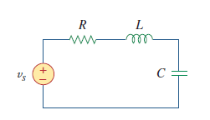

*Example of a second order circuit.*

**# Zero-Input response,** **Zero-State response & Full response:**

When it comes to solving a circuit, it is possible to split up the solution into two parts, the Zero-Input response, and the Zero-State Response to get the Full Response of the given circuit.

**The Zero-Input response** is the response of the system to the initial conditions, with the input set to zero.

**The Zero-State Response** is the response of the system to the input, with initial conditions set to zero.

**The complete or Full Response** is simply the sum of the Zero-Input response and Zero-State response.

1. Draw a differential circuit and an integral circuit separately, and use an oscilloscope to observe differences between two waves.

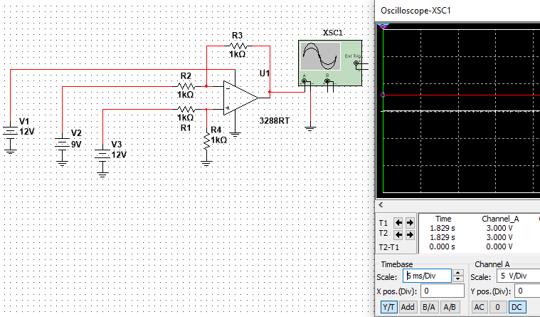

*A Differential Circuit*

The circuit above is a differential circuit based on 3288RT op-amp. It measures the difference between two voltage sources V2 and V3 and V1 is the power source of the op-amp. From the view of the oscilloscope we can see in the channel 1 we get a voltage difference of 3 volt which is the difference between the two voltage sources V2 and V3.

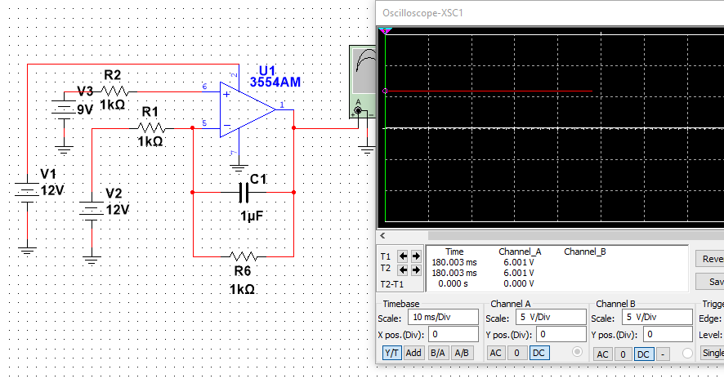

*An Integral Circuit*

Above shown an integral circuit based upon 3554AM op-amp which outputs the integral of the two voltage sources V2 and V3. From the oscilloscope we can see the output value is 6 volts.